**bnnmmmm**

**hhjpppppp**

**Product and Sales Analysis**

**Abstract**:

This product and sales analysis aims to assess the performance of a specific product within a given timeframe. The analysis focuses on various key performance indicators (KPIs) to understand the product's market presence, sales trends, and potential areas for improvement. The objectives include identifying factors contributing to sales growth or decline, exploring customer behavior, and making informed recommendations for future strategies.

**Objectives**:

* Sales Performance Evaluation: Analyze historical sales data to identify trends, peaks, and troughs in product sales.
* Market Positioning: Assess the product's competitive standing, market share, and pricing strategy effectiveness.
* Customer Segmentation: Categorize customers based on demographics, buying habits, and preferences to tailor marketing strategies.
* Product Improvement: Identify areas where the product can be enhanced or diversified based on customer feedback and market demands.
* Sales Forecast: Utilize historical data and market insights to project future sales trends.

### **Data Reading and Processing**

The sample sales data used in this example for analysis has the following columns −

| Order_Number | Product_type | Quantity | Price_Each | Order_Date | Address |
| --- | --- | --- | --- | --- | --- |

* Order Number − Unique number for each placed order.
* Product_Type − Category of the product
* Quantity − quantity of the product ordered
* Price Each − Price per unit
* Order Date − Date and time when the order was placed
* Address − Address to which the product was delivered.

We will have to import pandas and numpy which can be used to read and process the sample sales data. Here is the code to read the data −

The sample sales data can be found on the Kaggle platform [**here**](https://www.kaggle.com/datasets/kyanyoga/sample-sales-data).

### **Example**

import pandas as pd

import numpy as np

import io

from google.colab import files

uploaded = files.upload()

# read csv data

Sales_data = pd.read_csv(io.BytesIO(uploaded['sample_sales_data.csv']), encoding='cp1252')

Sales_data.sort_values(by=['ORDER_NUMBER'])

### **Output**

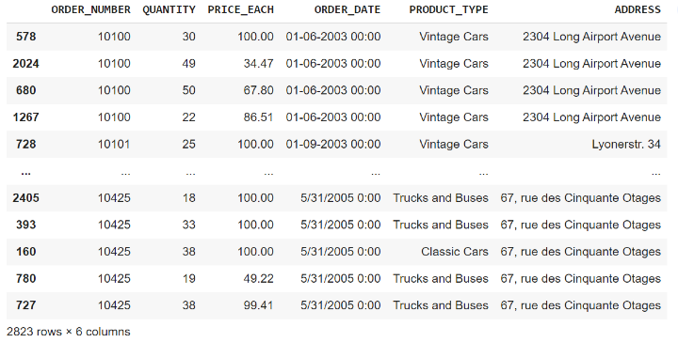

Once we have read the data, we have to do the processing of the data. The Order Date column needs to be converted to a DateTime object and we can extract month and year from the order date and add a new column for a month, year, and total sales. The code for data cleaning and processing is shown below −

### **Example**

Sales_data['ORDER_DATE'] = pd.to_datetime(Sales_data['ORDER_DATE'])

Sales_data['MONTH'] = Sales_data['ORDER_DATE'].dt.month

Sales_data['YEAR'] = Sales_data['ORDER_DATE'].dt.year

Sales_data['TOTAL_SALES'] = Sales_data['QUANTITY'] * Sales_data['PRICE_EACH']

Sales_data.sort_values(by=['ORDER_NUMBER'])

### **Output**

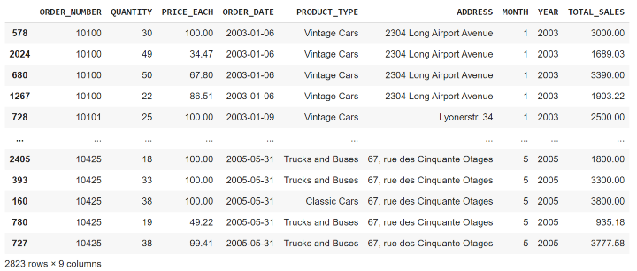

The new column month, year, and toatal_sales will help us analyze the sales trend over time. Now we can use these columns to plot different plots using the matplotlib library to get some insights from the sample_sales_data.

### **Data Visualization**

Till now we have read and processed our data to use it to plot different plots using the matplotlib library in Python. Matplotlib provides line, bar, and scatter plots to visualize the data.

### **Visualization of total sales over time**

To visualize the total sales over time we can plot a line graph using matplotlib.To visualize that we have to −

* Group the data by year and month
* Create a line chart using matplotlib
* Set the title and axis labels
* Display the chart

### **Example**

### **Example**

import matplotlib.pyplot as plt

# Group the data by year and month

sales_by_month = Sales_data.groupby(['YEAR', 'MONTH']).sum()['TOTAL_SALES'].reset_index()

# Create a line chart

plt.plot(sales_by_month.index, sales_by_month.values)

# Set the title and axis labels

plt.title('Total Sales by Month')

plt.xlabel('Month')

plt.ylabel('Sales ($)')

# Display the chart

plt.show()

### **Output**

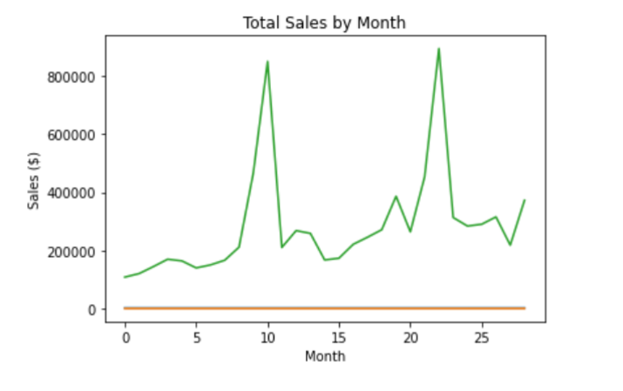

**Conclusion**:

The analysis revealed key insights into the product's sales performance. Sales have shown a steady growth pattern over the past year, driven by effective market positioning and an understanding of customer segments. However, there are opportunities for improvement through product diversification and continued customer segmentation. The sales forecast suggests a positive trajectory, provided strategies are adapted to changing market conditions and consumer preferences. This analysis provides a foundation for informed decision-making and future growth strategies.